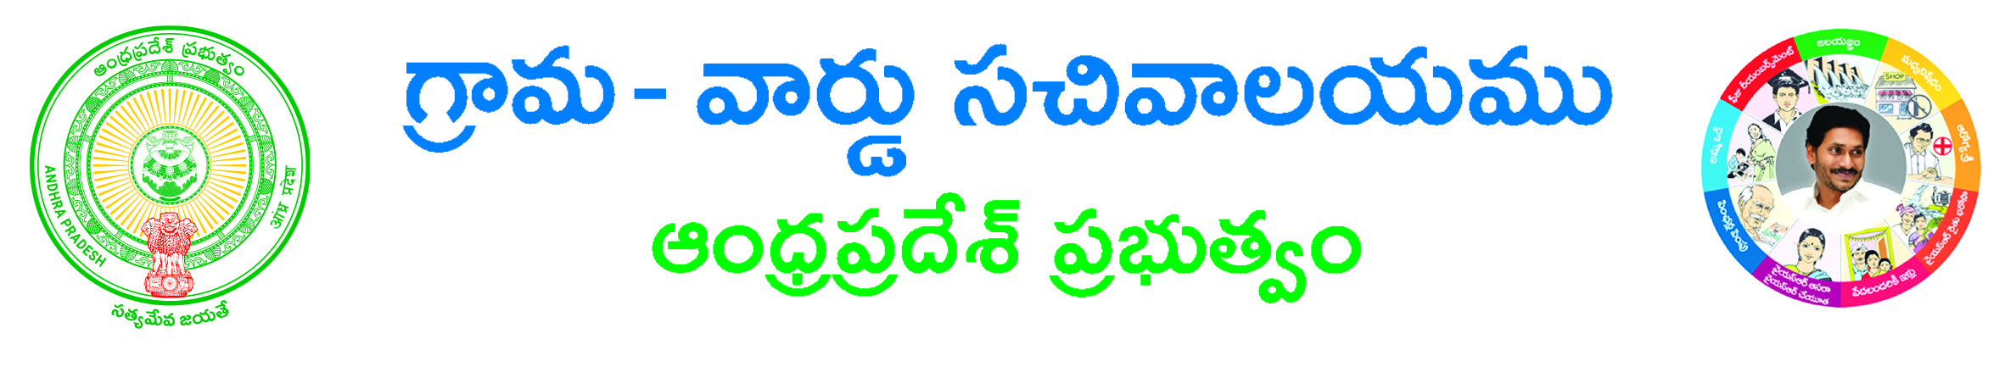

APPLICATION FOR DEATH CERTIFICATE
(Write in Capital Letters)

CIRCLE / LOCALITY :

1. Date Of Death :
2. Name of the Deceased :
3. Sex of the Deceased :
4. Name of the Father of the deceased :
5. Name of the Mother :
6. Place of Death :
(Tick the appropriate entry a, b, c below and give the name of the Hospital/Institute or the
Address of the House where the Death took place. If other place give location)
a) Hospital/Institution Name :
b) House Address :
c) Other place :
7.No.of Copies Required :

8 a) Do you want the Death Certificate by Courier- Yes / No.
b) If Yes give Name and Address with Pin Code

Name & address. (Signature of the Applicant)
Telephone No:

Note:- Death certificate will be issued subject to entry found Registered with in DEATH RECORDS-C&DMA/PANCHYATS.

